**DETECTION OF EMOTION OF A PERSON BASED ON SOCIAL INTERACTIONS ON DIFFERENT SOCIAL MEDIA**

*Submitted in partial fulfilment of the requirements for the degree of*

*Bachelor of Technology*

*by*

Himasri Tipirineni (147154)

Gajam Venu Gopal (147118)

Kavya Manjusha Tiruveedhula (147125)

*Under the esteemed guidance of*

**Dr.T.Ramakrishnudu**



Department of Computer Science and Engineering

National Institute of Technology Warangal

2014-2018

**APPROVAL SHEET**

The project work entitled **Detection of emotion of a person based on social interactions on different social media** by **T.Himasri, G.Venu Gopal, T.Kavya Manjusha** is approved for the degree of Bachelor of Technology in Computer Science and Engineering at National Institute of Technology Warangal during the year 2017-18.

**Examiners**

**Supervisor**

**_________________________**

Dr.T.RAMAKRISHNUDU

Assistant Professor, CSE Dept.

**Chairman**

Dr.R.B.V.SUBRAMAANYAM

Head of Department, CSE

NIT Warangal

Date: __________________

Place: __________________

**DECLARATION**

We declare that this written submission represents our ideas in our own words and where others’ ideas or words have been included we have adequately cited and referenced the original sources. We also declare that we have adhered to all principles of academic honesty and integrity and have not misrepresented or fabricated or falsified any idea/ data / fact / source in our submission. We understand that any violation of the above will be a cause for disciplinary action by the Institute and can also evoke penal action from the sources which have thus not been properly cited or from whom proper permission has not been taken when needed.

______________________________

(Signature)

Himasri Tipirineni

147154

Date: _________

______________________________

(Signature)

Gajam Venu Gopal

147118

Date: _________

_______________________________

(Signature)

Kavya Manjusha Tiruveedhula

147125

Date: _________

**NATIONAL INSTITUTE OF TECHNOLOGY WARANGAL**

**DEPARTMENT OF COMPUTER SCIENCE AND ENGINEERING**



**CERTIFICATE**

This is to certify that the project work entitled “**DETECTION OF EMOTION OF A PERSON BASED ON SOCIAL INTERACTIONS ON DIFFERENT SOCIAL MEDIA**” is a bonafide record of work carried out by T Himasri(147154) ,G Venugopal(147118) and T Kavya Manjusha(147125), submitted to the faculty of Computer Science and Engineering Department, in partial fulfilment of the requirements for the award of the degree of Bachelor of Technology in Computer Science and Engineering at National Institute of Technology, Warangal during the academic year 2017-2018.

Dr. T. Ramakrishnudu Dr. R.B.V. Subramaanyam

Project Guide Head of the Department

Department of CSE Department of CSE

NIT Warangal NIT Warangal

**ACKNOWLEDGMENT**

We consider it as a great privilege to express our deep gratitude to many respected personalities who guided, inspired and helped us in the successful completion of our project.

We would like to express our deepest gratitude to our guide, Dr. T. Ramakrishnudu, Department of Computer Science and Engineering, National Institute of Technology, Warangal, for his constant supervision, guidance, suggestions and invaluable encouragement during this project. He has been a constant source of inspiration and helped in each stage.

We are grateful to Dr. R B V Subramaanyam , Head of the Department, Computer Science and Engineering, National Institute of Technology, Warangal for his moral support to carry out this project.

We are very thankful to the Project Evaluation Committee, for their strenuous efforts to evaluate our projects.

We wish to thank all the staff members in the department for their kind cooperation and support given throughout our project work. We are also thankful to all of our friends who have given valuable suggestions and help in all stages of the development of the project.

Tipirineni Himasri (147154)

Gajam Venugopal(147118)

T Kavya Manjusha(147125)

**ABSTRACT**

It is very important these days to manage emotion levels. With the busy lives of people now-a-days, a lot are experiencing mood changes and various kinds of emotions frequently. Health problems caused by negative emotions include depression and anxiety, sleep problems, weight problems, digestive issues and heart diseases. Hence it becomes a matter of significant importance to detect the emotional status of a person before it might turn into some chronic problems. However, the usually existing methods for emotional state detection depend on physiological devices and image processing, making the detection of emotion complicated and costly. Now a days popularity of social media has increased rapidly. People are interested to share their everyday activities, express their views, opinions, thoughts on various social media platforms like Twitter, Facebook, Snapchat etc making it feasible for the usage of these platforms for detecting emotional status of people. In our work, we ﬁnd that emotional state of users is related in many instances to that of his/her friends in social media platforms, and we use a large-scale datasets collected from real-world social media platform like Twitter to study the relationship between the users’ emotional states and social interactions.

Usage of real online social media data, we first investigate the relationship between users’ emotional states and their tweeting content, public engagement and behavioral patterns. Then we define two types of emotional-related attributes: 1) tweet level attributes from a single tweet including text, images and social interactions; 2) user level or statistical attributes through their weekly social media postings, taking advantage of the information of tweeting time, tweeting types and linguistic styles. To aggregate content attributes with statistical attributes, we further use a convolutional neural network (CNN) with cross auto encoders to fill the missing modalities. Finally, we propose a model which uses Cross Auto Encoders with Support Vector Machines (SVM) to use the two types of user scope attributes to detect users’ emotional state. Results obtained from the experiments depict that the proposed model is effective and efficient on detecting emotional state from social media data.

.

**CONTENTS**

1. Introduction 1
   1. Twitter 2
      1. Tweets 2
   2. Emotions 3
      1. Positive Emotions 3
      2. Negative Emotions 3
   3. Effects of social media on health 3
   4. Social media’s role in emotion detection 4
   5. Existing methods for emotion detection 4
   6. Machine Learning 4
      1. Importance of Machine Learning 5
      2. Popular Machine Learning Methods 5
2. Related Work 6
3. Problem Statement 8
4. Attributes categorization and definition 10
5. Model Framework 16
   1. Architecture 17
   2. Cross Auto Encoder 18
   3. Support Vector Machines 20
6. Experimental Results 21
   1. Data Pre-processing 21
   2. Experimental Setup 26
   3. Observation and Analysis 27
   4. Results Analysis 30
7. Conclusion 36
8. References 37

**List of Figures**

* 1. Structure of a tweet 2
  2. Architecture of our model 17
  3. Model of Cross auto encoder 19

6.1 Collected tweets’ Directory structure 23

6.2 Sample tweets 24

6.3 Effect of replies on emotional state 28

6.4 Effect of past tweets on the present emotional state of a person 28

6.5 Effect of tweeting textual style on the emotional state 29

6.6 Effect of some of the most common used word categories in Twitter 30

6.7 Accuracy graph 31

6.8 Precision graph 31

6.9 RECALL graph 32

6.10 SVM Confusion matrix 32

6.11 Accuracy graph of comparison models 33

6.12 Precision graph of different models 34

6.13 RECALL graph of different models 34

6.14 F-1 score graph of different models 35

**List of Tables**

* 1. Tweet level attributes 14
  2. User level attributes 15
  3. Dataset 1 25
  4. Dataset 2 25
  5. Accuracy of comparison models 33
  6. Precision of different models 34
  7. RECALL of different models 34

6.6 F-score of different models 35

**CHAPTER 1**

**INTRODUCTION**

Negative emotional state detection remains a serious problem at the present stage. Detection and managing the emotional state before it turns into severe problems is of great importance. In recent years, several efforts have been done for emotion detection by researchers from different areas. They have developed several strategies to measure emotions, including psychological questionnaire based interviews and physiological signal based measures. However, these methods have their limitations in several aspects. Psychological questionnaires typically contain a varied range of queries designed by psychologists. People are usually unwilling to try these questionnaires unless they need to. Physiological strategies usually require professional devices to measure users’ physiological and biochemical properties and need specialists to analyze the acquired data.

With the quick development of social networks, individuals are widely using social media platforms to share their thoughts and feelings. Individuals post tweets containing text and pictures on micro-blog platforms to share opinions, express emotions, record daily routines and communicate with friends. We can acquire linguistic and visual content which will indicate negative emotion related symptoms. This makes the detection of users’ emotional state detection through their tweets and posting patterns from social networking platforms possible.

Various micro blogging sites provide a common platform for its users to discuss and share their everyday activities, views & information regarding various topics/subjects in an informal and casual manner. In recent years, Facebook, Twitter etc. have become some of the booming social networking sites all over the world. Among these various sites Twitter is one of the most feasible platforms for users to express their emotion.

**1.1 Twitter**

Twitter[16] is an online news and social networking service where users post and interact with messages, "tweets," restricted to 140 characters. Registered users can post/put up tweets; however individuals who are unregistered can only read them. Twitter has been compared to a web-based Internet Relay Chat (IRC) client. Users access Twitter through its website interface, SMS (Short Message Service) or a mobile device app.

**1.1.1 Tweets**

Tweets are publicly visible by default, but senders can restrict message delivery to just the people following them. Users may subscribe to other users’ tweets – this may be known as “following” and subscribers are known as “followers” or “tweeps”, a portmanteau of Twitter and peeps. When you decide to follow another Twitter user, that user's tweets appear in reverse chronological order on your main Twitter page. Individual tweets can be forwarded by other users to their own feed, a technique known as a "retweet". Users can also “like”/”favorite” individual’s tweets.

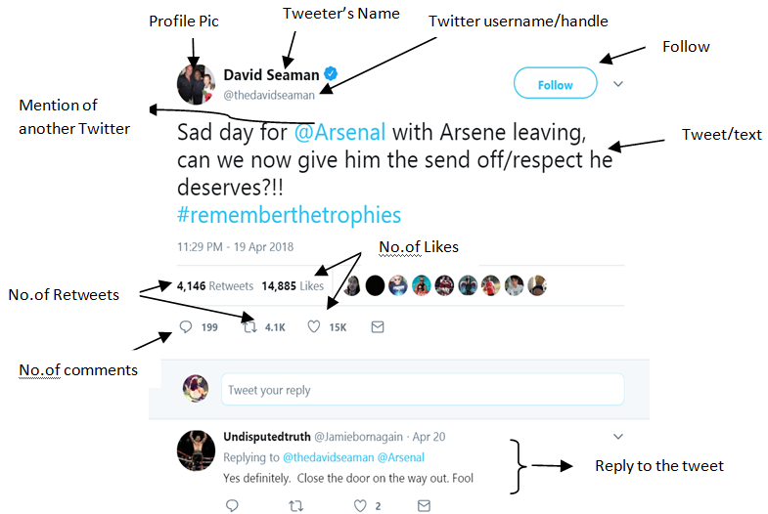

Fig 1.1 : Structure of a tweet

**1.2 Emotions**

Emotions can be classified as negative and positive emotions.

**1.2.1 Positive Emotions**

Positive emotions can be considered as a feeling that has the lack of negativity, such that there is no discomfort or pain. The most common positive emotions that can be identified are joy, gratitude, pride, peaceful/serenity, interest, hope, etc. There are also other positive emotions that can be considered such as the emotion felt when helping others. So, satisfaction and relief can also be considered as positive emotion

**1.2.2 Negative Emotions**

Negative emotions can be described as any feeling which makes you to be miserable and sad. These emotions make you dislike yourself and others, and takes away your confidence levels. The five main categories of negative emotions include

1) sadness (stress ,depression, despair etc)

2) anger ( irritation, frustration, rage etc)

3) anxiety (fear, worry, nervous, panic,etc)

4) guilt

5) shame/embarrassment.

Whenever a person is feeling negatively emotional it may be determined as one of the five emotions mentioned above (and also more than one of these types could be experienced at the same time).

**1.3 Effects of Social Media on Health**

Negative emotions are impossible to avoid and everyone feels them at anytime. They may be difficult, but they don’t have to be stressful and once they become stressful it can lead to serious health problems such as sleep problems, digestive problems, depression and anxiety, heart disease, weight problems, thinking and memory problems, etc. Each person reacts differently to different situations. What is stressful to one person may not be stressful to another. Some of the common major events that can cause for negative emotion or trigger stress include major life changes, work or school, relationship difficulties, financial problems, negative self-talk, unrealistic expectations etc.

**1.4 Social Media’s Role in Emotion Detection**

Now a days more people are interested to share their daily events and interact with friends through social network. This social media information can be used for representing and finding out the individuals behavior patterns through large-scale social networks. It can be observed that people who are negative emotioned are more likely to be less active in social media. Similarly, during a social interaction one person’s negative mood can be transferred to the other person.

**1.5 Existing Methods for Emotion Detection**

Many efforts have been made to develop convenient tools for individual emotion detection in recent years. Researchers are trying hard to use pervasive devices like personal computers and mobile phones for routine emotion detection. Hong L. et al., [1] proposed StressSense for human stress detection from human voice using smart phones. Paredes, P. et al.,[2] investigated the initial lab evidence of the use of a computer mouse in the detection of stress. However, such applications depend on collecting one’s real-life data, which is tedious. It makes stress detection unsuitable to normal life, and can't be used widely in more people.

**1.6 Machine Learning:**

Machine learning is a form of artificial intelligence (AI) that provides computer systems with the ability to analyze without being explicitly programmed. Machine learning explores the study and construction of algorithms & analytical models that can learn from and make data-driven predictions or decisions, via constructing a model from sample inputs.

These models allow engineers, data scientists, researchers, and analysts to "produce reliable, repeatable decisions and results" and find "hidden insights" through learning from historical relationships and trends in the data.

Few widely-publicized instances of machine learning applications are mentioned below:

* The Google self-driving car
* Recommendation systems similar to that of and Amazon and Netflix etc.,
* Knowing customers’/ individuals’ views on a specific product/topic on Twitter?

**1.6.1 Importance of Machine Learning**

The elements behind the popularity of ‘Data Mining’ and ‘Bayesian Analysis’ are also the motive behind the expanded interest on this area. Some of these factors encompass increasing varieties and volume of available data, reasonable data storage and an inexpensive and extra powerful computational processing.

All the above mentioned factors make it possible to swiftly and automatically produce models, which could analyze more complicated huge volumes of data and give more accurate and reliable results. This results in the building of precise and error-free models, thus helping the organization in identifying worthwhile opportunities or keeping off unexpected risks and make better decisions without human intervention.

**1.6.2 Popular Machine Learning Methods:**

Machine learning tasks are generally categorized into three extensive classes, relying on the nature of the learning "signal" or "feedback" available to a learning system. These are “Supervised Learning”, “Unsupervised Learning” and “Reinforcement Learning”. Some of the popular machine learning methods are Deep Neural Networks, Support Vector Machines, K-Nearest Neighbors, Linear Regression etc.

**CHAPTER 2**

**RELATED WORK**

In this section, we present a concise review of the related work including Research on Content based Emotional state Detection in micro blog sites, Research on Statistical based Emotional state Detection in Social Networks, Research on leveraging Social Interactions for Social Media Analysis and Various machine learning approaches for cross-media data modeling.

*1)Research on Content based Emotional state Detection in micro blog sites*:

Computer based detection, analysis and application of emotional state detection in social networks has attracted a lot of attention in recent years [13]. Emotional state at tweet level is predicted on linguistic features and classification approaches. We studied the daily tweets of users and analyzed that tweeting content has robust correlation with the emotional state of a individual. However, only single tweets don’t seem to be sufficient for correct detection of emotion of a person. It depends on various other factors as well as the social interaction between the users.

2)*Research on Statistical based Emotional state Detection in Social Networks*:

While tweet-level emotion detection expresses that particular moment emotion in a single tweet, people’s emotion or psychological state is usually more lasting, changing over different time periods [14]. The time period chosen should be appropriate and should facilitate in correct detection of emotional state. Some recent works [7] proposed to detect user’s emotional states from social media by learning user-level presentation via a deep neural network on consecutive series of tweets in a certain time period.

3) *Research on Leveraging Social Interactions for Social Media Analysis*:

Social interaction is one of the most important features of social media platforms. The social interaction shows the way users are connected across the social media. It tells about the influence of others posts, comments etc. on their emotional state. Now many researchers are focusing on leveraging social interaction information to help improve the effectiveness of social media analysis. Fischer and Reuber [10] analyzed the relationships between social interactions and users’ thinking and behaviors, and found out that Twitter-based interaction can trigger effectual cognitions. Yang et al. [8] leveraged comments on Flickr to help predict emotions expressed by images posted on Flickr. However, these work mainly focused on the content of social interactions, e.g., textual comment content, while ignoring the inherent structural information like how users are connected.

4) *Various machine learning approaches for cross-media data modeling*

Micro-blog data is typically cross media data. Data in social networks is usually composed of consecutive and inter-related items from different sources ,making it be actually cross-media data. It is very tedious to take care of the heterogeneous cross-media data. Therefore various approaches have been developed for handling the heterogeneous cross media data. Among them ,a cross-media learning method based on Deep neural network or Support vector machine, can be widely used for detecting emotional states and corresponding categories from a tweet/post. The work done in the recent paper [9] design a cross-media learning method based on DNN, and leverage the model for detecting psychological states and corresponding categories from a single tweet.

**CHAPTER 3**

**PROBLEM STATEMENT**

In this section, we present the related definitions to state the problem of our project formally.

Let V be a set of users on a social network, and let |V| represent the total number of users. Each user $v_{i}$ Є V posts a series of tweets. Let P be the tweet level attributes set associated with the tweet. B be the user level attributes set.

Each tweet may contain text, pictures, or video content. The series of tweets correspond to individuals’ social interactions on the social network.

Some definitions involved in formulating the problem are as below:

**Definition 1** : Emotional state: The emotional state x of a user $v_{i}$ Є V at time t is denoted by a triple (x, $v_{i}$,t) or in short as $x_{i}^{t}$. The emotional state here usually takes three values i.e. $x_{i}^{t}$ Є { 0,1,-1}. Each value corresponds to an emotional state. Specifically 1 represents positive emotional state,0 represents neutral emotional state and -1 represents negative emotional state. Let $X^{t}$ represent the set of emotional states of all users at time t.

**Definition 2** : Time varying tweet level Attribute matrix :A tweet level attribute matrix describes each tweet-specific features. This matrix usually contains content attributes which are taken from the content of a single tweet. The content of a tweet from social media basically consists of text, pictures and social interaction.

Each user in V is associated with a set of tweet level attributes P. Let $Y^{t}$ be |V| x |P| attribute matrix at time t, in which every row $y_{i}^{t}$ x $t_{i}$ corresponds to a user, each column corresponds to a tweet level attribute, and an element $y_{i,j}^{t}$ is the $j^{th}$ attribute value of user $v_{i}$ at time t .

**Definition 3** : Time varying user level Attribute matrix :A user level attribute matrix describes user-specific features. This matrix usually contains statistical attributes. Statistical attributes are summarized from users’ tweets in a specific sampling period. Here we defined statistical attributes in three various aspects to differentiate between the positive and negative emotioned users.

Each user in V is associated with a set of user level attributes B. Let $Z^{t}$ be |V| x |B| attribute matrix at time t, in which every row $z_{i}^{t}$ x $t_{i}$ corresponds to a user, each column corresponds to a user level attribute, and an element $z_{i,j}^{t}$ is the $j^{th}$ attribute value of user $v_{i}$ at time t .

**Problem Statement**:

Given a network of users and their attribute matrices. The emotional state of a set of users is already defined, known as labeled users($V_{L}^{t})$. Whereas the emotional state of other set of users is not defined, known as unlabeled users($V_{U}^{t}$). The aim of our model is to learn a function which uses the information of the labeled users and find the emotional state of the unlabeled users.

Given a series of T partially labeled time-varying attribute-augmented networks {=(,,,,) | t Є {1,2…T} }, the objective is to learn a function

f : { $G^{1}$, $G^{2}$,… $G^{t}\}→\{ X^{1},X^{2},…, X^{t}\}$

where $V_{L }^{t}$ is the set of labeled users

$V_{U}^{t}$ is the set of unlabeled users

$Y^{t}$ is the time varying tweet level attribute matrix of all users at time t.

$Z^{t}$ is the time varying user level attribute matrix of all users at time t.

$X^{t}$ is the set of emotional states of all users at time t.

**CHAPTER 4**

**ATTRIBUTES CATEGORIZATION AND DEFINITION**

The social media data is a typical type of cross-media data. It contains text, emoticons, pictures and social interactions. Besides these various attributes, the usage behavior of social media in the sampling period also contain useful information regarding the emotion detection.

Therefore, in order to take advantage of both content information present in single cross-media social network tweet and the behavior of social media usage in sampling period tweets ,we defined two sets of attributes to measure the differences of the negative and positive emotioned users.

1. Tweet level attributes
2. User level attributes

1). **Tweet level attributes:**

Tweet level attributes explains about the contents of a single tweet. We defined textual, pictorial and social/public attention attributes from each part of a tweet.

1. Textual attributes:

Users usually express their emotions through tweets. Hence we can measure the emotions in a tweet with the help of textual attributes. To describe these attributes, we use a psychological dictionary named “Language Inquiry and Word Count Dictionary.”

It is composed of almost 4500 words which are categorized into over 60 categories.

Textual features are extracted based on the LIWC library[4].

Based on this dictionary, text content related features are defined as followed :

* Positive and negative emotion words (2 dimension vector) : The count of positive and negative words in a single tweet is maintained in this vector.
* Positive and negative emoticons (2 dimension vector) : The count of positive and negative emotion icons is maintained in this vector. Emoticons are usually used in social media platforms to express users’ emotional states . They can be used for the emotion detection. Twitter uses Unicode as the representation for all emojis so that they can be extracted directly.
* Most commonly used punctuation marks (4 dimension vector): The count of the punctuation marks such as ! , . … is maintained in this vector. It has been observed that these punctuation marks have significant effect on the user’s emotional state. According to the associated emotional words , this attribute is used to signify the intensity of emotion in a tweet, either positive or negative.
* Degree Adverbs and Emotion words (2 dimension vector): Degree of emotions is also expressed by degree adverbs. For example, “I feel a little bit sad “and “I feel terribly sad” expresses various levels of negative feelings. Here, we use a number range of 1-3 to represent neutral, moderate and severe degrees of positive expression and minus to represent the negative expression.

1. Pictorial attributes:

Based on affective image classification and color psychology theories , we obtain the following features as the visual representation for emotion detection.

* Five-color theme (15 dimensions) : It is a combination of five dominant colors in the HSV color space. It has been observed that it has an important impact on human emotions according to psychology and art theories.
* Saturation (2 dimensions): The mean value of the saturation and its contrast.
* Brightness (2 dimensions): The mean value of brightness and its contrast.
* Warm or cool color (1 dimension): Ratio of cool colors with hue([0-360]) in the HSV space between 30 and 110.
* Clear or dull color (1 dimension): Ratio of colors with brightness ([0-1]) and saturation less than 0.6.

Thus the pictorial attributes of a tweet contribute a 21 dimensional vector for the emotional state detection.

1. Social attributes:

Besides the text content and image content of a tweet, some additional features also indicate the tweet’s social attention from one’s friends. They can also imply one’s stress state to some degree.

* Public attention (3 dimensional vector) : It signifies the public attention on the tweets made by the users. These include number of likes, replies and retweets.

**2).User level attributes:**

User level attributes are summarized from users’ tweets in a specific sampling period. Users may express their emotional state in a series of tweets rather than a single tweet. We define user level attributes from three aspects to measure the differences between positive and negative emotional states based on users’ sampling period tweet postings. The details of the user level attributes are described as follows:

1. Behavioral attributes :

We define a set of behavioral measures for users, including tweeting time and tweeting types, based on the sampling period tweet postings. These measures are described as follows:

* Public engagement (3 dimension vector): It specifies about the number of retweets, mentions and replies made by the user in the sampling period.
* Tweeting hour (24 dimension vector): Tweeting hour can indicate users’ daily routines at different times of the day. The vector contains information about the number of tweets in a day at various point.
* Tweeting category (4 dimension vector): Users usually post tweets on social media with various intentions, making the tweets to be of different types. We can divide users’ tweets into mainly four categories: pictorial tweets (Contains only image and no text) ,General tweets (tweets that are originally posted by users),

Questioning tweets (tweets asking for information) ,sharing tweets (tweets that contain outside hyperlinks and other sharing tweets).

1. Tweeting textual style (16 dimension vector):

We have observed that there are 16most commonly used category of words from LIWC2015 that relate to general life and public activities on social media. i.e., personal pronouns, home, work, money, religion, death, health, ingestion, friends, family, singular pronouns, plural pronouns, reward, achieve, affiliation, swear. We counted the no. of words related to every category and stores in a vector of dimensions 16.

1. Attributes related to replies:

These correspond to the attributes related to the replies given by the user. These replies also have an effect on the emotional state of the person.

* Words (10 dimension vector) : It gives the count of 10 frequent categories of words specified in LIWC 2015 from replies (or comments) for the posts of the sampling period.
* Emojis (2 dimension vector) : It gives the count of positive and negative emoticons present in the replies given by the user.

1. Past Tweets:

The tweets in the past sampling period can affect the emotional state of the person in the current sampling period.

* Previous sampling period tweets (3 dimension vector) : It gives the count of positive , negative and neutral tweets made in the previous sampling period.

The below Table 4.1 and Table 4.2 depicts the Tweet level and User level attributes.

Table 4.1 Tweet Level Attributes

|  |  |  |  |
| --- | --- | --- | --- |
| Tweet Level Attributes | | | |
| Type | Attribute Name | Length of Vector | Description |
| Textual | No. of words related to positive and Negative Emotion | 2 | Count of positive emotion words and Negative emotion words |
| No. of emojis related to positive and Negative Emotion | 2 | Count of positive and negative emotional emojis |
| Count of most commonly used Punctuation marks | 4 | Most commonly used punctuations count. They are ( . , ! …) |
| Degree Adverbs and Emotion Words | 2 | Degree adverbs like terrible, bit etc. have effect on emotion. For example, "I am terribly tired" has more negatively emotional than " I am little bit tired". |
| Pictorial | Five Dominant Colors | 15 | RGB (red, green, blue) values of five most dominant colors in the Picture, has proved to have effect of human emotion |
| Saturation | 2 | The mean value of saturation and its contrast |
| Brightness | 2 | The mean value of brightness and its contrast |
| Warm/Cool color | 1 | Ratio of cool colors with hue ([0-360]) in the HSV space in [30, 110] |
| Clear/Dull color | 1 | Ratio of colors with brightness ([0-1]) and saturation < 0.6 |
| Social | Public attention | 3 | Number of likes, replies and retweets |

Table 4.2 User level Attributes

|  |  |  |  |
| --- | --- | --- | --- |
| User Level Attributes | | | |
| Type | Attribute Name | Length of Vector | Description |
| Behavioral | Public engagement | 3 | No. retweets, mentions, replies made by the user in the sampling period |
| Tweeting Hour | 24 | No. of tweets made in the hours in 24-length vector |
| Tweeting category | 4 | Four main tweet types are 1) Pictorial Tweet (contains only image not text), 2) General Tweet ( tweet originally made by the user) 3) Questioning Tweet ( tweet asking for an information), 4) Sharing tweeting ( tweet having hyperlinks and information sharing tweets) |
| Tweeting textual style | 16 | 16 most commonly used category of words from LIWC2015 that relate to General life and public activities on social media. i.e., personal pronouns, home, work, money, religion, death,  Health, ingestion, friends, family, singular pronouns, plural pronouns, reward, achieve, affiliation, swear. We counted the no. of words related to every category and stores in a vector of dimensions - 16 |
| Replies | Words | 10 | 10 Dimensional integer vector containing the count of words of 10 frequent category of words specified in LIWC2015 from replies( or comments) for the posts of the sampling period |
| Emojis | 2 | Number of positive emojis and negative emojis. |
| Past Tweets | Previous sampling period tweets | 3 | Number of positive, negative and neutral tweets made in the previous sampling period |

**CHAPTER 5**

**MODEL FRAMEWORK**

In this section, we describe about the challenges involved and the model frame work for our proposed model.

**Challenges**

There are several challenges involved in this work. Some of the challenges faced and their corresponding solutions are given below as:

1）Challenge 1: Social media platforms contain huge data. It is very difficult manually to label the data . So, efficient methods are required to automatically label the acquired data.

Our solution: Inspired by [3] , we have constructed a emotion based-twitter-posting database using some sentence patterns like “I feel stressed/sad/happy/joy” etc. as the ground truth label for emotional state detection from social media data.

2 ） Challenge 2: Attributes in a tweet or a post are associated with various modalities and the some of the components/modalities may be missing , which is a major issue in social media platforms. The tweets made by a user may vary from person to person and from time to time.

Our solution: We designed a convolutional neural network (CNN) with cross auto encoders with the aim to fill the missing modalities /components which is useful for user-level emotion detection.

3）Challenge 3: Detecting emotional state in user-level is more hectic than in single tweet-level, since both the overview and detailed attributes should be taken care of.

Our solution: We propose an emotional state detection model based on SVM to combine both the tweet level attributes and user level attributes together. The SVM model along with CNN forms a distinct integral model which can get the attributes from single tweets and detect user-level continuous emotional state.

In order to handle these challenges, we use a convolutional neural network(CNN). CNN is capable to learn the features and fill in the place of the missing modalities. Here,we shall discuss about the detailed architecture of our model.

**5.1 Architecture**

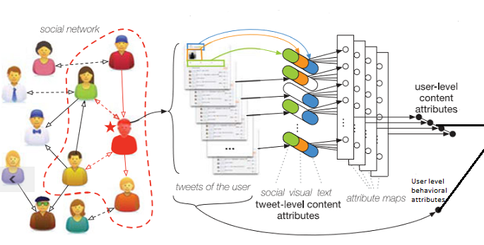

Emotional state

$$x_{i}^{t}$$

SVM

Fig 5.1: Architecture of our model

The above figure depicts the architecture of our model. There are two types of information that are available from data processing and can be given as the initial stage inputs, i.e., tweet-level attributes, user-level attributes. First, a CNN with cross auto encoders (CAE) to generate user-level content attributes from tweet-level attributes is designed and then these attributes are given to the Support vector machines for the detection of emotional state. We obtain attributes from each tweet of the individual to form tweet-level attributes with the help of data processing. There might be some missing modalities in the extracted attributes. The tweet-level attributes are given to cross auto encoders (CAEs) .The CAEs are embedded in a CNN that will aggregate attributes from CAEs into the user-level content attributes by pooling each attribute map. The user-level content attributes and user-level posting behavior attributes together form the user-level attributes. The pooled attributes from the CAE are then given to the SVM to classify the tweets as either positive ,negative or neutral emotioned. Then this model is compared with various versions of the machine learning methods such as Deep Neural Networks, Decision trees and linear regression methods to find the efficiency of our model.

**5.2 Cross Auto Encoders**

Cross Auto Encoders are mainly used to fill the missing modalities in the attributes obtained from the tweets of the users. The tweets of a user may contain text ,images and the social interaction. All the tweets will not contain all three attributes. Therefore, we need to fill these missing modalities.

We Denote the textual, pictorial, and social interaction attributes of a tweet by $u_{t}$, $u_{I}$, and $u_{S}$, the CAE is formulated as follows:

v = f ($w_{t}u_{t}$ + $w_{I}u_{I}$ + $w_{S}u_{S}$ +c)

$(\tilde{u_{t}}$, $\tilde{u_{I}},\tilde{u_{S}}$) = f ($\tilde{w}$ v + $\tilde{c}$)

Where v is the modality unaffected representation

$w_{t}$, $w_{I}$, $w_{S}$ and c are the parameters used in the encoder of CAE.

${\tilde{w}}_{t}$, ${\tilde{w}}_{I}$, ${\tilde{w}}_{S}$ and $\tilde{c}$ are the parameters used in the decoder of CAE.

f(.) is the activation function.

Here in our model, we used f as a sigmoid activation function.

f(y) = $\frac{1}{1+exp⁡(-y)}$.

${\tilde{u}}_{t}$, ${\tilde{u}}_{I}$, ${\tilde{u}}_{S}$ are the reconstructed input modalities which were missing originally.

Fig 5.2 : model of cross auto encoder

The base idea of CAE is to make the model to reconstruct missing modalities in the training stage and to learn the correlation between the cross modalities from the data. While training the cross auto-encoder, we use training data which includes all the three modalities such as textual, pictorial and social interaction attributes. We disable the visual or social interaction modalities manually and give this data to the CAE. We require the model to reconstruct all the three modalities .Hence the CAE is trained with the incomplete set of modalities $\tilde{u_{t}}$, $\tilde{u_{I}}$, $\tilde{u_{S}}$ that inputs from one or two modalities missing and require it to reconstruct all the three.

The CAE is trained with the stochastic gradient descent approach. Assuming all the parameters in the CAE to be Ф , we define energy function as follows

J($\overline{u_{t}},\overline{u_{I}}$, $\overline{u_{S}}$; Ф) = $\frac{1}{2}$ ($∑{ || \tilde{u_{M}} - u_{M}||}^{2}$) + $\frac{α}{2}$ ($∑{ || w_{M}-\tilde{w_{M}}||}^{2}$)

MЄ t,I,S

MЄ t,I,S

This energy function is used initially in [9]. Here ,the ﬁrst term signifies the measure of the reconstruction accuracy. The second term signifies the measure of the weight decay regularization term which avoids parameters in the model from arbitrarily divergence.α is the regularization weight. Giving data with different modalities as input, the training of CAE can be done and a modality unaffected representation can be learnt.

We can get user-level content attributes from a series of single tweets from a user in a sampling period to describe a user’s emotional state over that sampling period. All the attributes of tweets in a sampling period form a one-dimensional series. Hence we used a 1-Dimension CNN in our model.

Attribute maps of the CNN lists the CAE units which are connected by an instance. These instances with some missing modalities are taken by the CAE units to generate the modality-unaffected attribute maps. These CAE units acts as filtering devices in the one dimension CNN and forms one feature map. Pooling is one amongst the necessary steps in order to recapitulate the obtained attribute maps into lesser instances of attributes. Though we have various number of tweets from different users in different weeks, the sampling period remains the same. Hence we each attribute map is pooled into a single pooled attribute. There are more typically two pooling operations: max-pooling and mean-pooling. Here, mean pooling is applied to the attribute maps. Since we pool over the period of sampling time we use the method mean-over-time pooling that can be calculated by adding up all the activations for the user level attributes. For tweet level attributes pooling is done by the mean-over-tweet method. After pooling the output is fed into the SVM.

**5.3 Support Vector Machines**

A support vector machine is a distinguishable classifier formally defined by a separating hyper plane. In other words, when we give a labeled training data , the model outputs an efficient hyper plane which makes new examples given into categories. When two categories of data or two sets of data points are given , SVM determines a hyper plane that separates these two categories.

Hence whenever a new example is given to this SVM , it can be categorized according to the hyper plane. In this model we have to categorize the given tweet or series of tweets into either positive, negative emotioned or neutral emotioned .We give rfg as a kernel to the SVM model and gives the pooled attributes from the CAE units as input. We then obtain the percentage of positive , negative or neutral emotions of the user. We have implemented SVM using the Scikit tool.

**CHAPTER 6**

**EXPERIMENTAL RESULTS**

**6.1 Data pre-processing**

We considered Twitter [16] as a source for data. For data processing, first we need to get raw tweets data from twitter. Secondly we need to preprocess and extract features from the raw tweets for observation and analysis.

**Data collection:**

Twitter has Official Twitter APIs [17] for developers to collect publicly available tweets. There are many tools that use the official APIs to collect data. We used tweepy [18] , a python library that use Twitter APIs.

We used the following to collect raw tweets. 1) Python [19] , 2) Tweepy and 3) Access Tokens given by Twitter APIs.

**Twitter REST APIs:**

There are two types of APIs given by twitter. They are REST APIs and Streaming APIs. REST APIs are standard APIs to get publicly available tweets while Streaming APIs are the advanced APIs that give real-time tweets based on search terms. We used REST APIs which are sufficient enough to collect required tweets data.

**Data extraction using python and tweepy**

Steps involved in collecting raw tweets data

1) Get access Tokens from Twitter APIs:

In order to access twitter REST APIs, We need to get access tokens from Twitter APIs. There are four tokens to be taken from Twitter APIs to collect required tweets data. They are 1) Consumer Key, 2) Consumer Secret, 3) Access Token and 4) Access Token Secret. Following are the steps to get the four tokens.

* Go to https://apps.twitter.com/ and log in with your twitter credentials.
* Click on “Create New App” button.
* Complete the form, check the “agree to the terms” check box and click on “Create your Twitter application” Button
* In the next page, click on “API keys” tab, and copy the application’s “API key” and “API secret”.
* Scroll down and click “Create my access token”

**2)** Collect tweets data:

In order to collect data, we need to select the twitter users whose tweets are being collected. We selected two set of users who are active in twitter. Then we collected their tweets for a period of four months. Total number of tweets collected is around 1.8 lacs. Following is the code snippet to collect data for a specific user.

All the tweets collected are stored in organized structured format.

The figure 6.1 depicts the organized structured format of the collection of tweets.

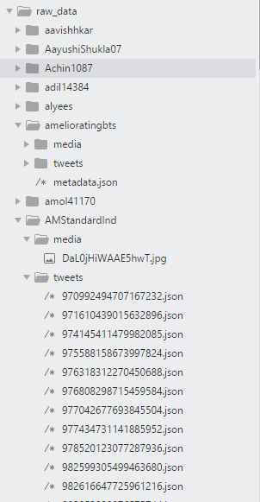

Image tweeted by user

Tweet object in .json format with ID as file name.

Directory containing tweets in .json format

User name: AMStandardlnd

Fig 6.1 : Collected tweets’ Directory Structure

**Data labeling:**

We labeled the tweets as positive tweet (1), negative tweet(-1) and neutral tweets(0) based on the common sentence patterns that expresses the emotion of a person such as “I feel sad”, “I feel happy”, “ I feel stressed”, “I am feeling better” etc., This method of labeling is proved to be effective in emotional analysis [3].

Now data is available for feature extraction, analysis, further processing.

The figure 6.2 shows the examples of the collected tweets and the emotion associated with these tweets.

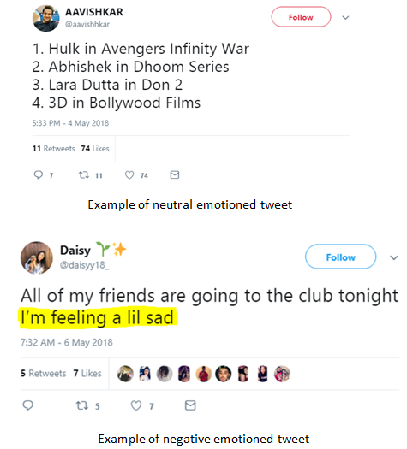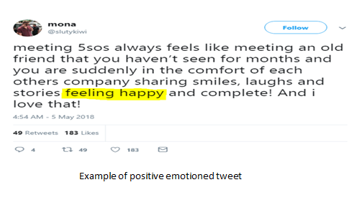

Fig 6.2 Figure depicting sample tweets

**Datasets Summary**

We collected 51 users tweet data from 01.2018 to 04.2018 as dataset1 and 62 users tweet data from 11.2017 to 02.2018 as dataset2. Details of the datasets are summarized in tables

Dataset 1: We have collected 51 users tweet data from 01.2018 to 04.2018 as dataset1

Table 6.1 Dataset-1

|  |  |  |  |
| --- | --- | --- | --- |
| Label | Positive | Negative | Neutral |
| No of tweets | 36507 | 14423 | 44719 |
| Average Number of Tweets per user | 715.8235 | 282.8039 | 876.8431 |
| Average Number of Tweets per day | 165.19 | 65.2624 | 202.3484 |
| Average Number of Tweets per week | 1106.273 | 437.0606 | 1355.121 |
| Average Number of Tweets per user per day | 7.5993 | 3.0023 | 9.3087 |
| Average Number of Tweets per user per week | 42.0104 | 16.5972 | 51.4603 |

Dataset 2: We have collected 62 users tweet data from 11.2017 to 02.2018 as dataset2.

Table 6.2 Dataset-2

|  |  |  |  |
| --- | --- | --- | --- |
| Label | Positive | Negative | Neutral |
| Number of Tweets | 39082 | 10955 | 44298 |
| Average Number of Tweets per user | 544.3226 | 164.6613 | 666.4839 |
| Average number of tweets per day | 209.6149 | 63.4099 | 256.6584 |
| Average number of tweets per week | 1298 | 392.6538 | 1589.3077 |
| Average number of tweets per user per day | 4.9593 | 1.5002 | 6.0723 |
| Average number of tweets per user per week | 26.1207 | 7.9017 | 31.983 |

**Feature Extraction**

Textual Features:

Features related to tweet text are extracted based on the LIWC dictionary [15]. We first made regular expressions related to all the category words specified in LIWC. Then we used the regular expressions to count the words related to LIWC in tweet text.

For features related to emojis, three regular expressions are made out of text related to emojis based on their sentiment [5]. They are regular expression made out of positive, negative and neutral emojis. These regular expressions are used to count the emojis present the tweet text.

Pictorial Features:

Features related to images are extracted using opencv library for python [20]. First the image is loaded in RGB color space [21] using opencv library and five dominant color features are extracted. Then the image is converted to HSV color space to extract remaining pictorial features.

Features related to behavior, public attention, replies are directly extracted from tweets itself.

**6.2 Experimental Setup**

After feature extraction, we saved the datasets and their labels in a mysql local database.We have also used OpenCV for the extraction of image features. Then we made tweet attributes to sampling period wise attributes by using CAE with pooling. After pooling ,SVM with RBF kernel is used to detect the emotional state.

In our experiment, we ﬁrst train and test our model on the dataset-1 . Our model is tested with other datasets such as dataset-2 to show effectiveness of the proposed model on different data sources .For all of our analysis, we compared our model with the following machine learning techniques.

Comparison Methods:

We compare the following classiﬁcation methods for user-level psychological stress detection with our model.

Logistic Regression (LRC) : It trains a logistic regression classiﬁcation model and then predicts users’ labels in the test set.

Support Vector Machine (SVM) : SVM is a popular and binary classiﬁer which is proved to be effective on a huge category of classiﬁcation problems. In our problem we use SVM with RBF kernel.

Deep Neural Network (DNN): It is a popular model that is good at classification problem. We used this model , with 3 hidden layers as it is proved to effective. We used sigmoid function as activation function and stochastic gradient descent algorithm as optimization algorithm.

Decision Trees: We also trained a decision tree with ‘gini’ criterion and compared the results.

K-nearest neighbors (KNN): We also made a KNN classifier with 3 neighbors and ball tree algorithm and compared it with our model.

We employed scikit-learn for the above methods.

Evaluation Measures:

For a complete investigation of the proposed methods, we consider the following aspects:

Effectiveness. We assess the detection performance of our model and comparison methods in terms of Accuracy (Acc.), Recall (Rec.), Precision (Prec.) and F1-Measure (F1) .

Efﬁciency. We assess efﬁciency of the methods by finding the CPU time of training each model and comparing them. All our experiments are performed on an x64 machine with 2.3 GHz intel Core i5 CPU and 4 GB RAM..

**6.3 Observation and Analysis**

We have observed that adding of certain attributes have significant change in the emotional state detection. Some of the results obtained by our observation are given as follows :

1. Effect of replies on the emotional state:

Fig 6.3 Figure depicting the effect of replies on the emotional state

When we observe the graph above , we can find that certain words such as death , anger , sad , family, leisure etc. have more ratio in negative emotion tweets compared to positive emotion tweets. Similarly certain words such as friend,posemo etc. have slightly more ratio in positive emotion tweets compared to negative emotion tweets.

1. Effect of past tweets on the present emotional state of a person:

Fig 6.4 Figure depicting the effect of past tweets

It has been surprisingly observed the past neutral tweets have a more negative impact compared to positive impact on the present emotional state. Similarly by default the previous positive tweets have more positive and the previous negative tweets have more negative impact on the present emotional state of a person.

1. Effect of tweeting textual style on the emotional state:

Fig 6.5 Figure depicting the effect of tweeting textual style

The observation made here states that the singular pronouns such as ‘you’ have more ratio in positive emotion tweets whereas ‘she/he’ and ‘I’ etc. have more ratio in negative emotioned tweets. Some of the plural pronouns such as ‘they’ have more ratio in negative emotion tweets .Some of the words such as negate and interrogate have more negative impact on the emotional state of the user.

1. Effect of some of the most commonly used word categories in Twitter:

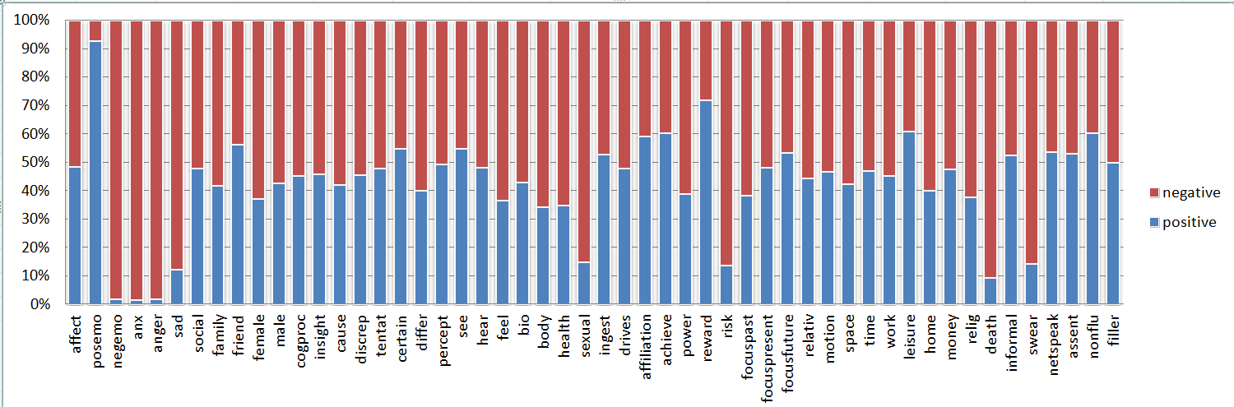

Fig 6.6 Figure depicting the effect of some common used word categories

The above graph shows the analysis of the usage of some of the commonly used words. The words in the categories posemo, friends, reward ,focus present and leisure etc. have more positive impact on the emotional state. The word categories such as negemo, anxious, anger ,risk, death and swear etc. has more negative impact on the emotional state of a person.

**6.4 Result Analysis:**

Observing the behavior of the model upon addition of some attributes, we have arrived at the following:

It is observed as shown in Fig 6.7 that the addition of past tweets to the existing attributes provides more accuracy.

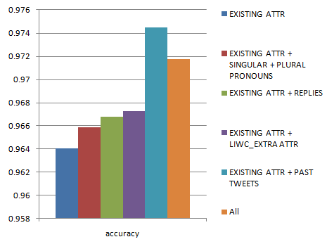

Fig 6.7 Accuracy graph

Fig 6.8 Precision graph

Fig 6.9 Recall graph.

The accuracy, precision and recall for our proposed model has been calculated. It has been concluded that due to adding of past tweets attribute the overall efficiency of the model has been improved.

**Confusion Matrix for SVM:**

After analyzing all the datasets , we arrived at the following confusion matrix for our model which is implemented using SVM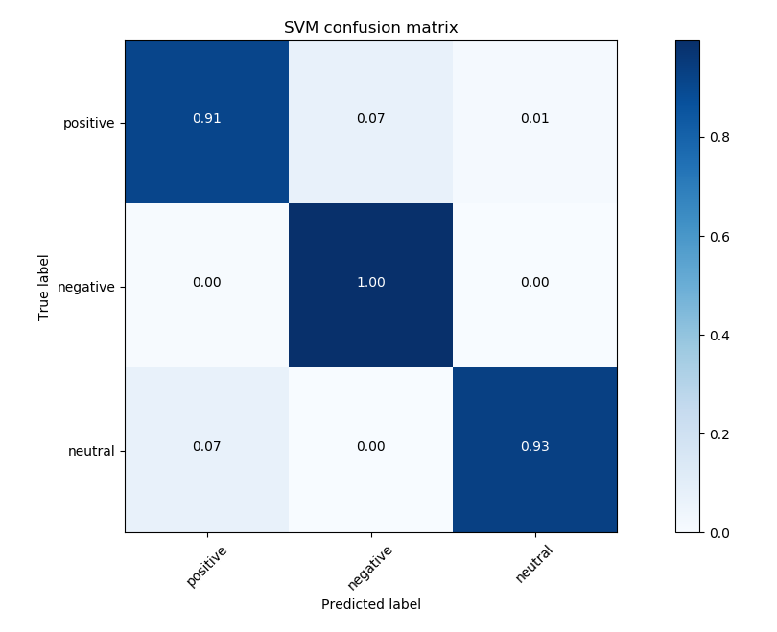Fig 6.10 Confusion matrix

**Comparision models:**

We compared our model with all the above models in accuracy. SVM model gave high accuracy compared to others while KNN being second with small different. Then we compared svm model to DNN with the other effective measures. It is found that CAE with SVM is better when compared to other models.

Accuracy for various models is obtained as:

Table 6.3 Accuracy for comparision models.

|  |  |
| --- | --- |
|  | accuracy |
| DNN | 0.511654 |
| LRC | 0.651959 |
| DTree | 0.958675 |
| Knn | 0.968749 |
| SVM | 0.972979 |

Fig 6.11 Accuracy graph for comparision models

It has been observed that accuracy obtained by DNN, SVM and kNN models is more compared to the other comparision models.

Table 6.4 : Precision for different models

|  |  |  |  |  |  |
| --- | --- | --- | --- | --- | --- |
| **Precision** | Dtree | knn | lrc | dnn | Svm |
| Positive | 0.84265 | 0.84058 | 0.484472 | 0.68423 | 0.846791 |
| Negative | 0.986025 | 0.996894 | 0.860248 | 0.98456 | 0.996894 |
| Neutral | 0.902256 | 0.909774 | 0.568974 | 0.78915 | 0.864662 |

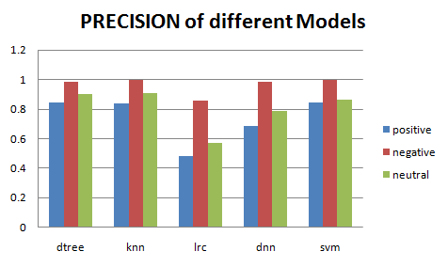

Fig 6.12 Precision graph for different models

Table 6.5 : Recall for different models

|  |  |  |  |  |  |
| --- | --- | --- | --- | --- | --- |
| **Recall** | Dtree | knn | lrc | dnn | Svm |
| Positive | 0.957746 | 0.958974 | 0.634146 | 0.678435 | 0.95338 |
| Negative | 0.904694 | 0.900421 | 0.621773 | 0.511111 | 0.901685 |
| Neutral | 0.931298 | 0.925313 | 0.546951 | 0.623541 | 0.966387 |

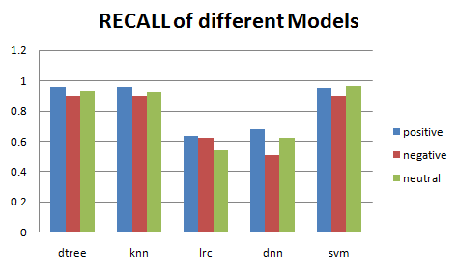

Fig 6.13 Recall graph for different models

Table 6.6 : F-score for different models

|  |  |  |  |  |  |
| --- | --- | --- | --- | --- | --- |
| **F-score** | Dtree | knn | lrc | dnn | Svm |
| Positive | 0.896519 | 0.895882 | 0.549296 | 0.68132 | 0.89693 |
| Negative | 0.94361 | 0.946205 | 0.721824 | 0.672901 | 0.946903 |
| Neutral | 0.916547 | 0.917478 | 0.557745 | 0.696638 | 0.912698 |

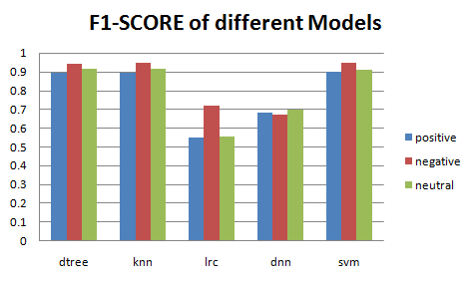

Fig 6.14 F1-score for different models

The precision, accuracy ,recall and f1-score obtained by various models have been shown in the above graphs. It has been observed that our proposed model has achieved more accuracy than the above comparision models.

**CHAPTER 7**

**CONCLUSION**

.

Throughout this project, we focus on a challenging problem of detecting emotional state of a person based on his/her interactions on social media platforms ,here twitter.The main contributions of our work are as follows:

1. We proposed a model based on Cross Auto Encoders(CAE) and Support Vector Machine(SVM) to leverage both user level and tweet level attributes for the detection of emotional state of a person.
2. Data labeling has been done using the ground-level truth sentence patterns like “I feel sad, happy etc” . This method of data labeling has reduced the human effort to manually label the data sets.
3. A variety of statistical attributes like behavioral attributes, social engagement and linguistic style attributes from users’ sampling period tweet postings have been proposed.
4. Testing of the model using various machine learning methods such as Deep Neural Networks (DNN), Logistic Regression(LR) etc has been done.

The results obtained showed us that proposed model is effective and efficient on detecting emotional state of user from micro-blog data.

**CHAPTER 8**

**REFERENCES**

[1] Lu, H., Frauendorfer, D., Rabbi, M., Mast, M. S., Chittaranjan, G. T., Campbell, A. T., ...& Choudhury, T. (2012, September). StressSense: Detecting stress in unconstrained acoustic environments using smartphones. In Proceedings of the 2012 ACM Conference on Ubiquitous Computing (pp. 351-360). ACM.

[2] Paredes, P., Sun, D., & Canny, J. (2013, May). Sensor-less sensing for affective computing and stress management technology. In Pervasive Computing Technologies for Healthcare (PervasiveHealth), 2013 7th International Conference on (pp. 459463). IEEE.

[3] Kamvar, S. D., & Harris, J. (2011, February). We feel fine and searching the emotional web. In Proceedings of the fourth ACM international conference on Web search and data mining (pp. 117126). ACM.

[4] Tausczik, Y. R., & Pennebaker, J. W. (2010). The psychological meaning of words: LIWC and computerized text analysis methods. Journal of Language and Social Psychology, 29(1), 24-54. DOI: 10.1177/0261927X09351676

[5] N. P. Kralj, J. Smailovi, B. Sluban, and I. Mozeti, “Sentiment of emojis,” Plos One, vol. 10, no. 12, 2015, Art. no. e0144296.

[6] H. Lin, et al., “User-level psychological stress detection from social media using deep neural network,” in Proc. ACM Int. Conf. Multimedia, 2014, pp. 507–516

[7]H. Lin et al., "Detecting Stress Based on Social Interactions in Social Networks," in IEEE Transactions on Knowledge and Data Engineering, vol. 29, no. 9, pp. 1820-1833,Sept.1.2017.DOI: 10.1109/TKDE.2017.2686382

[8] Y. Yang, et al., “How do your friends on social media disclose your emotions?” in Proc. 28th AAAI Conf. Artiﬁ. Intell., 2011, pp. 306–312.

[9] M. S. Granovetter, “The strength of weak ties,” Amer. J. Sociology, vol. 78, pp. 1360–1380, 1973.

[10] E. Fischer and A. R. Reuber, “Social interaction via new social media: (How) can interactions on twitter affect effectual thinking and behavior?” J. Bus. Venturing, vol. 26, no. 1, pp. 1–18, 2011.

[11] C. C. Chang and C.-J. Lin, “Libsvm: A library for support vector machines,” ACM Trans. Intell. Syst. Technol., vol. 2, no. 3, pp. 389–396, 2001.

[12] D. C. Ciresan, U. Meier, J. Masci, L. M. Gambardella, and J. Schmidhuber, “Flexible, high performance convolutional neural networks for image classiﬁcation,” in Proc. Int. Joint Conf. Artif. Intell., 2011, pp. 1237–1242.

[13] G. Coppersmith, C. Harman, and M. Dredze, “Measuring post traumatic stress disorder in twitter,” in Proc. Int. Conf. Weblogs Soc. Media, 2014, pp. 579–582.’

[14] F. A. Pozzi, D. Maccagnola, E. Fersini, and E. Messina, “Enhance user-level sentiment analysis on microblogs with approval relations,” in Proc. 13th Int. Conf. AI* IA: Advances Artif. Intell., 2013, pp. 133–144.

[15] <http://www.liwc.net> “Linguistic Inquiry and Word Count”

[16] <http://www.twitter.com>.

[17] <https://developer.twitter.com/>

[18] <http://www.tweepy.org/>

[19] <https://www.python.org/>

[20] <https://opencv.org/>

[21] <https://en.wikipedia.org/wiki/Color_space>



